**User Manual**

**for Ramen Order System**

**Group 102**

**1. System Overview**

This is an order system designed for the self-service administrator backstage management in a ramen restaurant.

In this system, customers can order the meal, sign up for the loyalty, log in, pay and get the ticket. More than one bowl of noodle could be ordered at the same order.

Managers could use this system to modify the price and storage of the items and check the sale statistic in different ways.

**2. Open the Program**

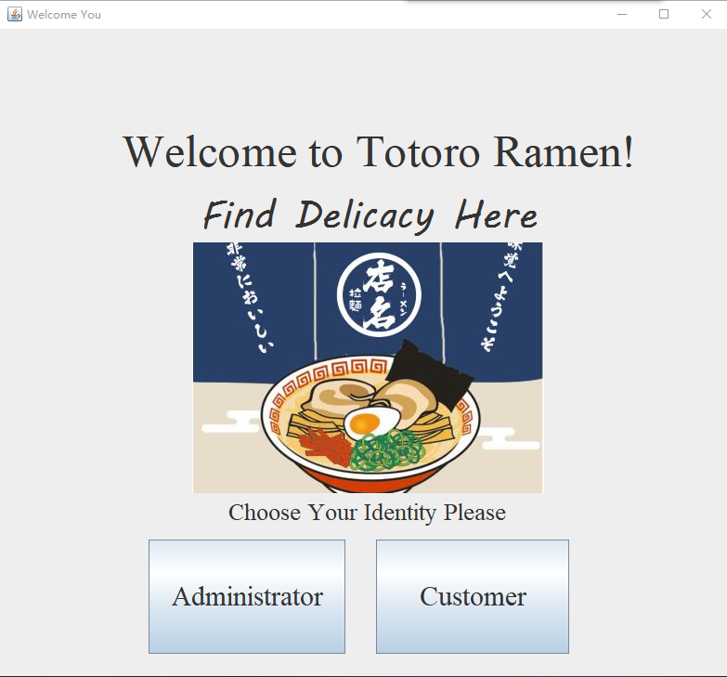

Open the program, you can see the interface, “Welcome to Totoro Ramen”. Then you can choose the identity, customer or administrator.

**2.1 Customer section**

If you choose customer, it means you are going to order.

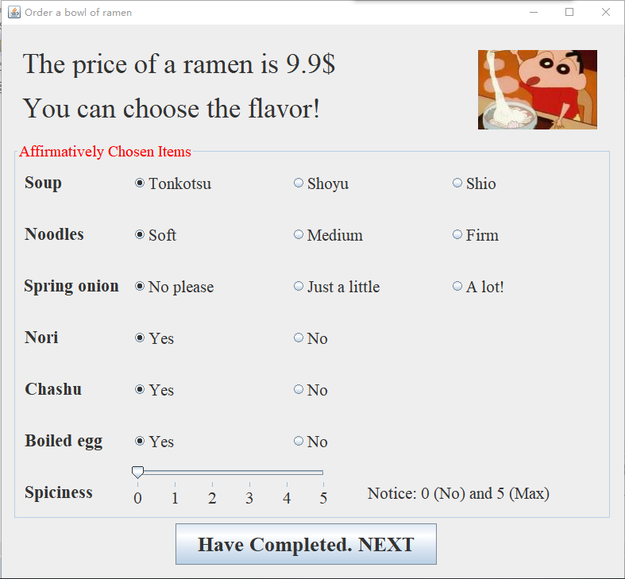

This interface shows the first step to order a bowl of ramen. You can choose the type of soup, noodles, the number of spring onion, and whether to put nori, chashu or boiled egg, and last, choose spiciness. Then you can press the button 13ca3578d5e7824e5eb0354f5b12783

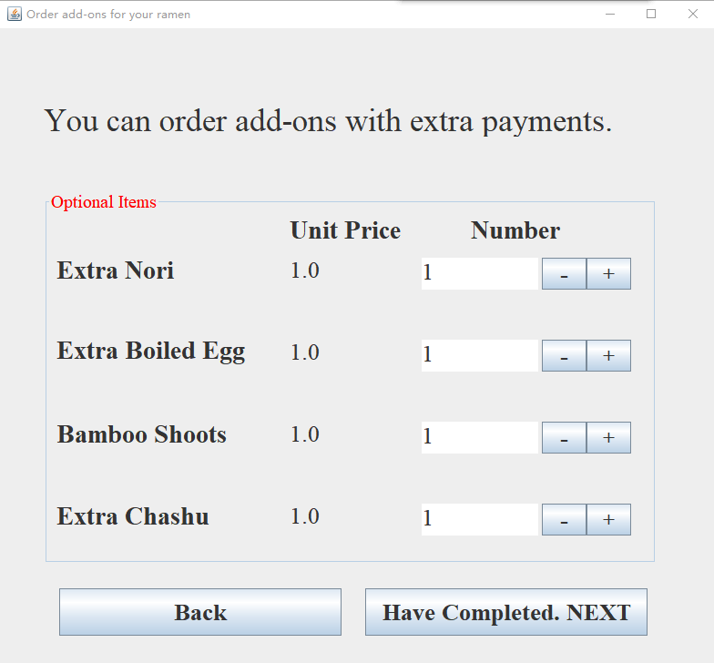

Then you can order add-on, for example extra nori, and you can add numbers you want. Then press the button 13ca3578d5e7824e5eb0354f5b12783

Then you can see your order .

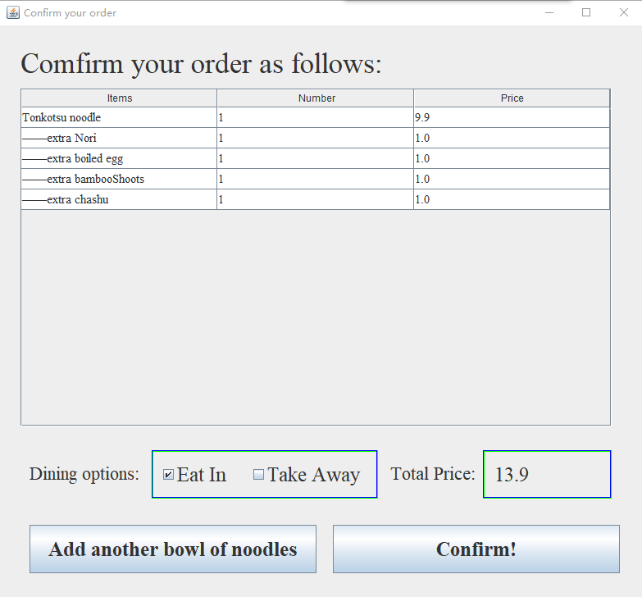

You have order one bowl of ramen successfully. Then you can add another one. Press 3fc009fd7d66d7b96b307c57b9798ea, then you can do it.

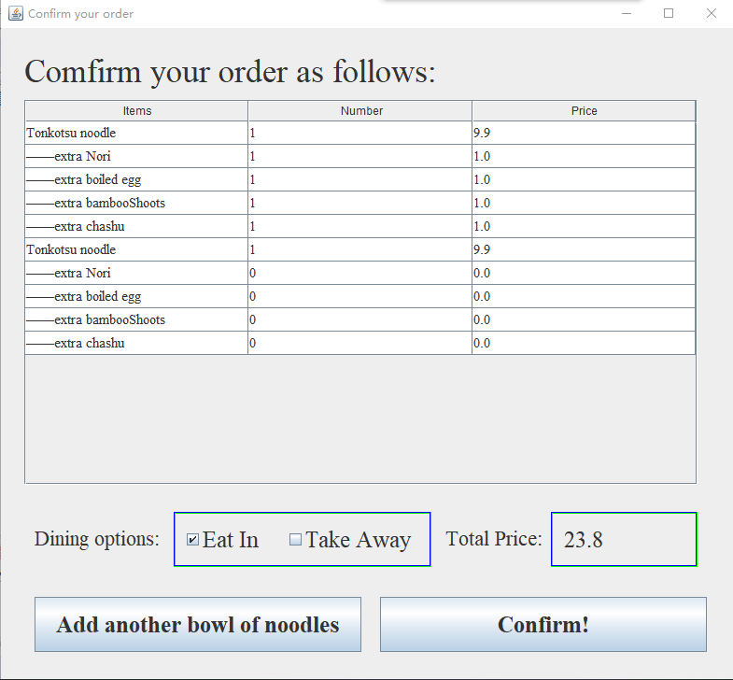

Your order becomes like this, with another bowl of ramen. Then you can press b917122af8cb5a4eb81c309477ca30c to go on.

Next is VIP confirming.

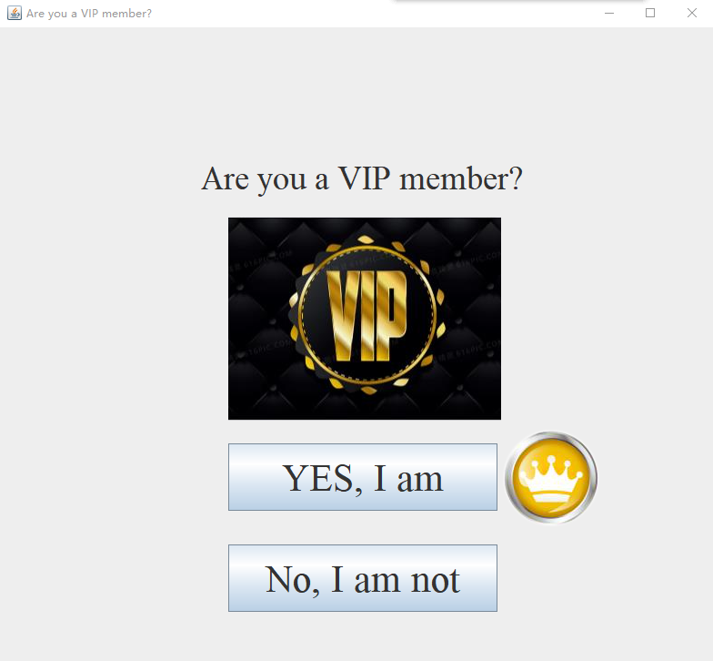

If you have been a VIP member, choose the first button with a crown. If not, press the second. For example, I am a VIP member, and I choose the first.

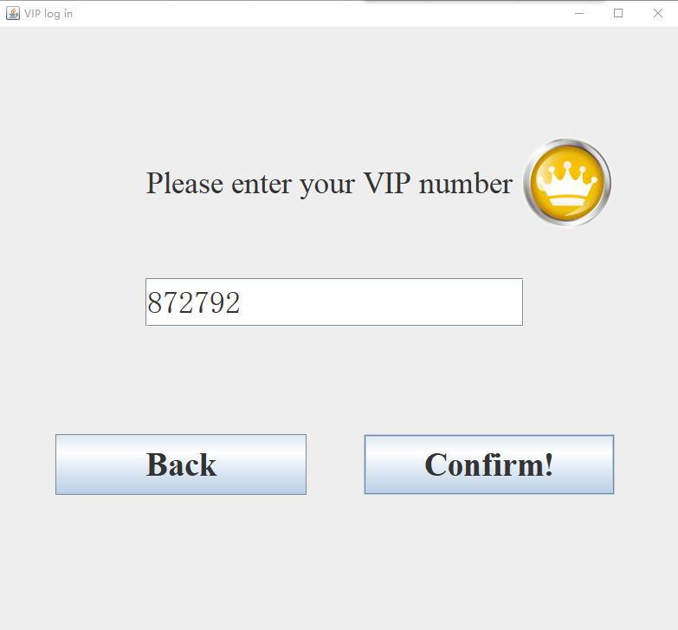

I entered my VIP number, and choose ddef66d90e22255d1f29ff9083c344f.

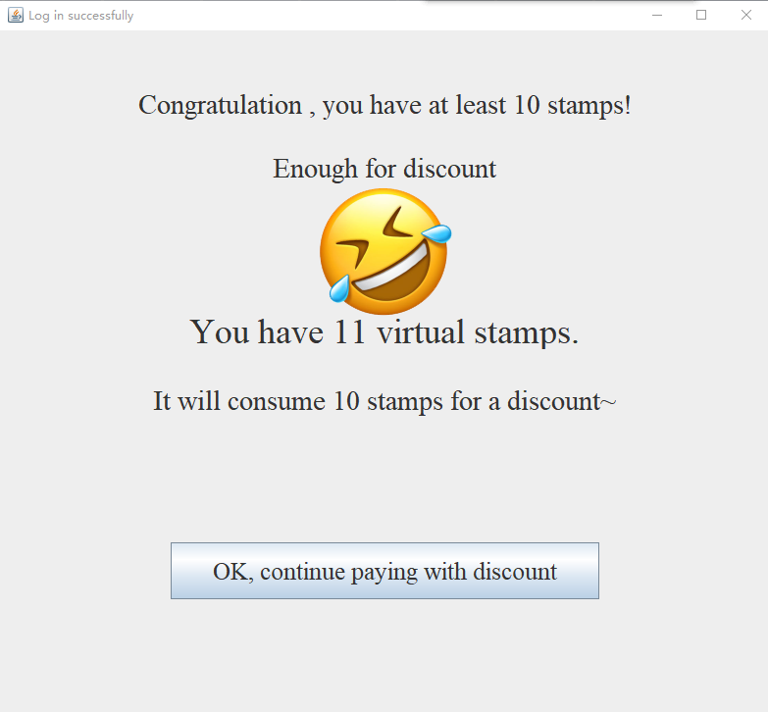

Congratulations, you have 11 virtual stamps, and 10 of them will be used for discount. You can press the button to go on.

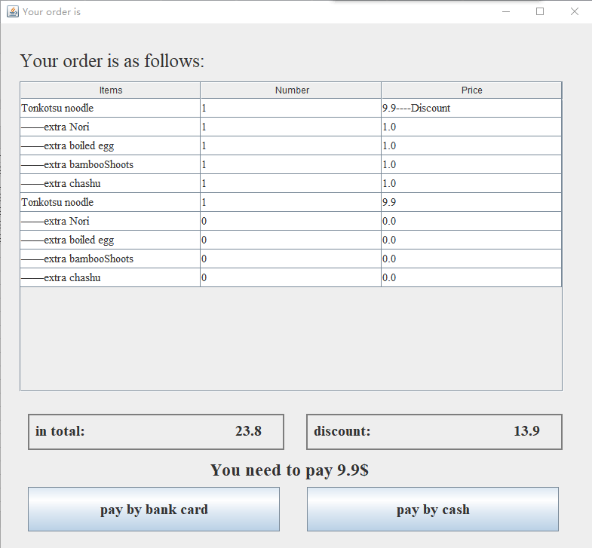

This interface shows your order again, and give you the price you need to pay. You can choose payment method, bank card or cash.

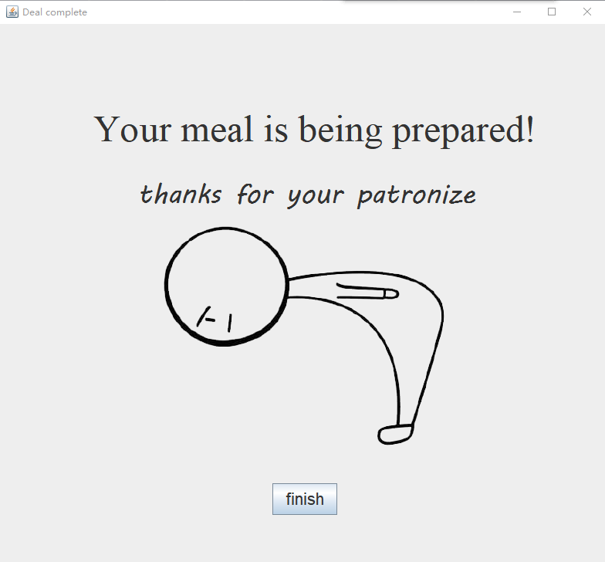

Then you have finished your order, and you can wait for your meal! The program shows its pleasure for your ordering.

However, if you are a VIP but you do not have 10 stamps, you will get this

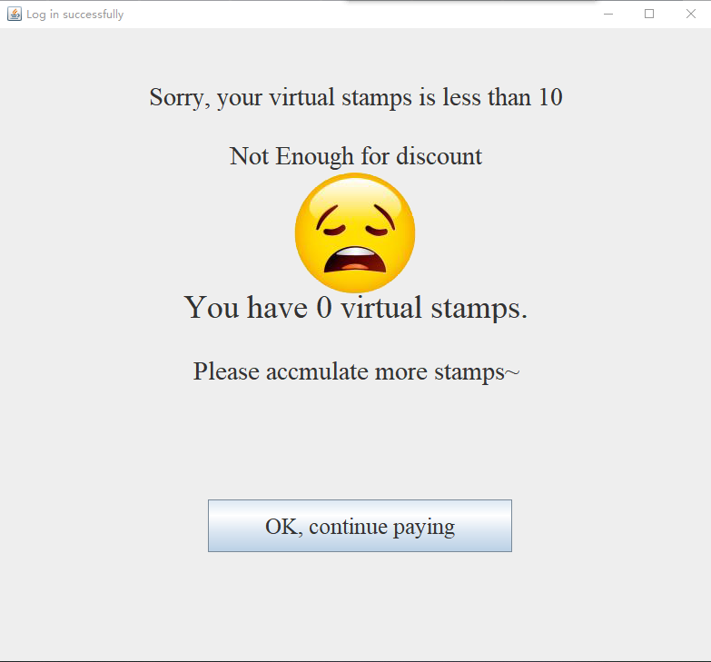

You need to accumulate more stamps. You need to press the button to go on.

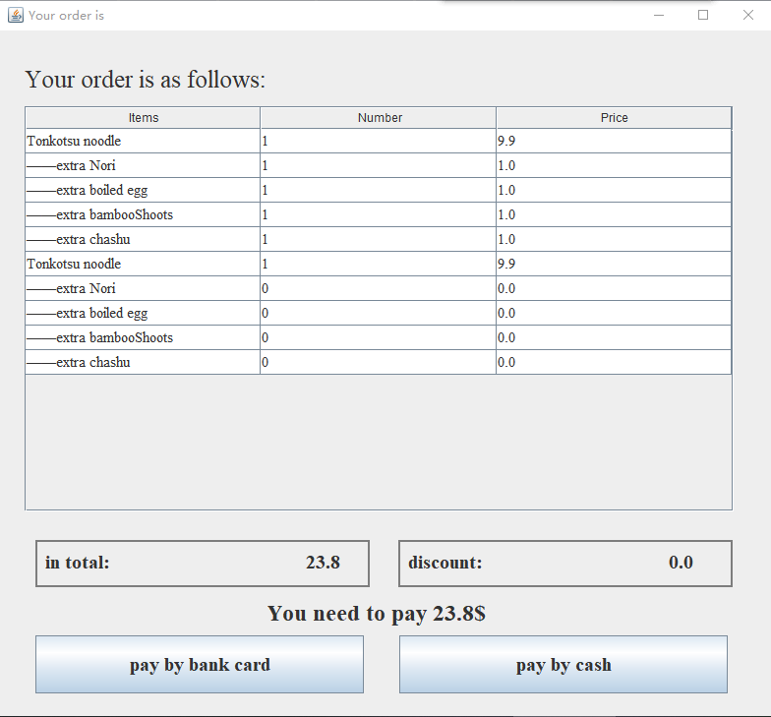

You can see your order once again, and of course, your discount is 0.0. Then you can choose the method to pay, by bankcard or cash. When you finish, you can also get the finish interface.

But if you are not a VIP member, you can only choose 1f330f08ec541aeffcb38909940475d. then you will get this interface.

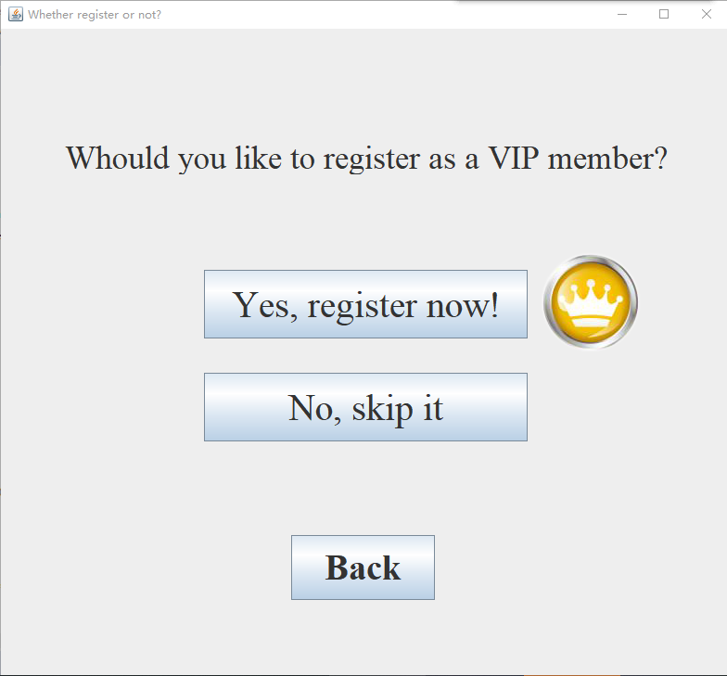

The crown is telling you that we want you to be a VIP, and if so, press 543989ce7a9c345a5765cd2a86f8e3f

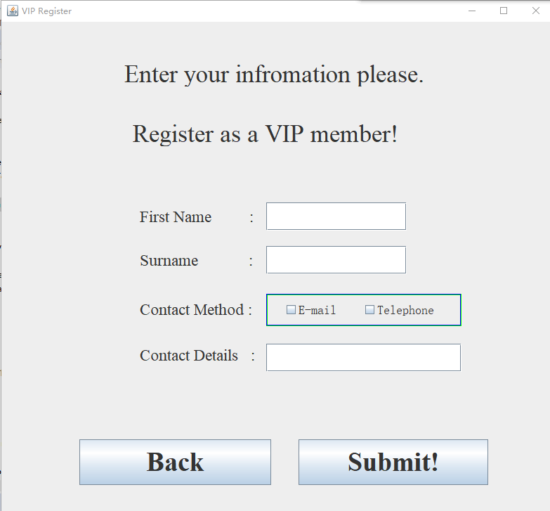

Then you need to fill in some information of yourself. Your name and your telephone number, or you can choose e-mail. Then press ac3b14603fc84ca3a8fd2da64359608.

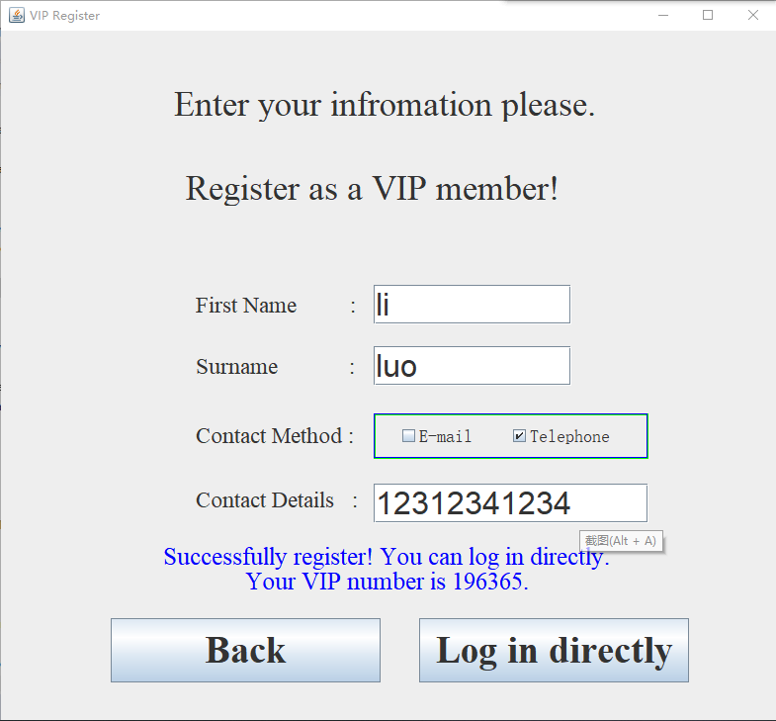

Like this, you have successfully register, and you get your VIP ID. Of course you have no virtual stamps right now, so you can go to payment interface by pressing 46293cca7cfe5e0d6519bcc2fecedde

After all the things, you will get a ticket.

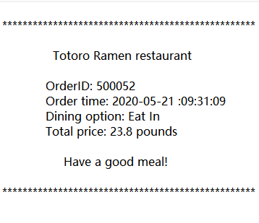

It shows your order ID, order time, dinning option and price.

That are all functions of customer section.

**2.2 Administrator section**



In the first interface, press 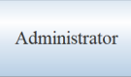, you can use the program as the boss of this restaurant.

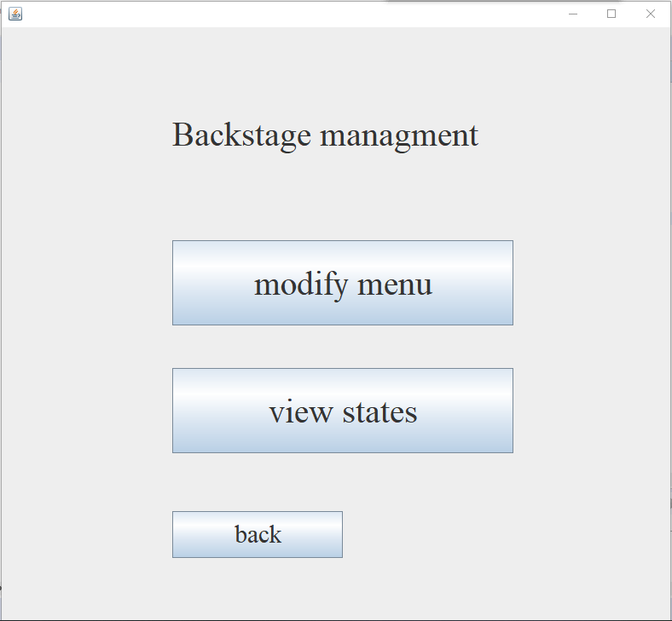

Then you inter the backstage management interface. You can choose one of these tow functions. If you press 3ada6cb23a218533ea3f9992da44c6f.

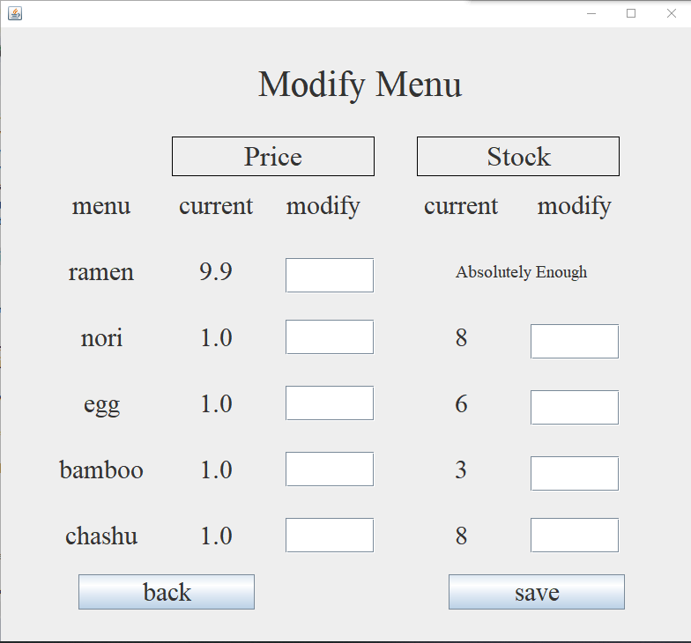

It shows the price of all the items and the stock right now. In the text boxes, you can modify the price and numbers. After modifying, press 8b51dce8dde4628fd7245fba30ddcc2.

Then it will go back to the backstage management.

If you press 

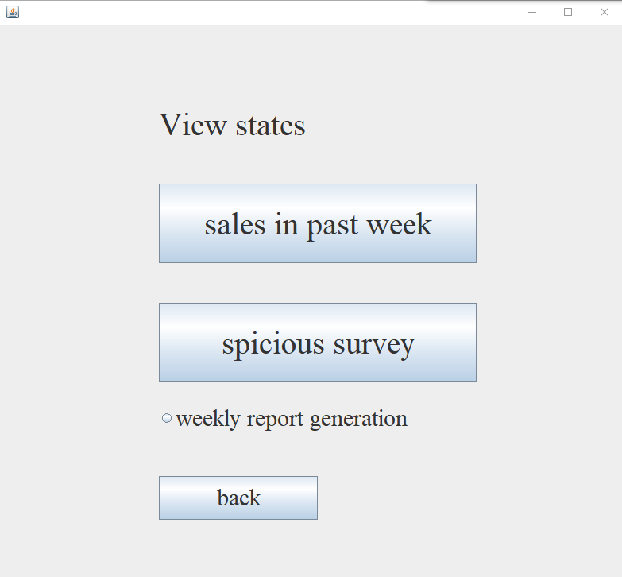

You can see the past week sales, form Monday to Sunday. And you can see the spiciness survey. If you press 11b5e444aa2831cc9c2219bcddabc6e:

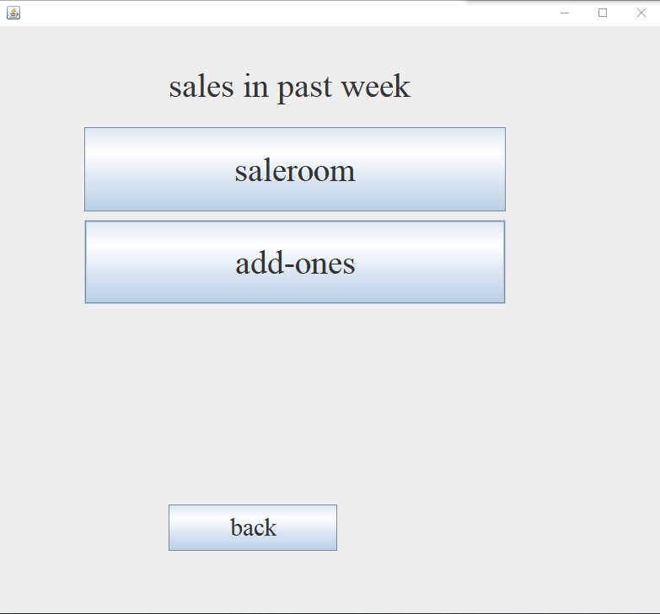

Then you can choose one of tow sales.

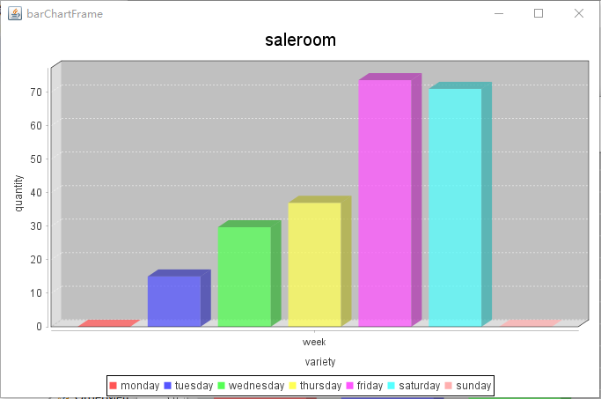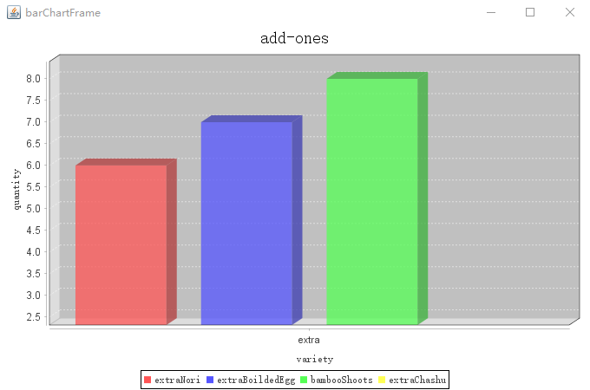

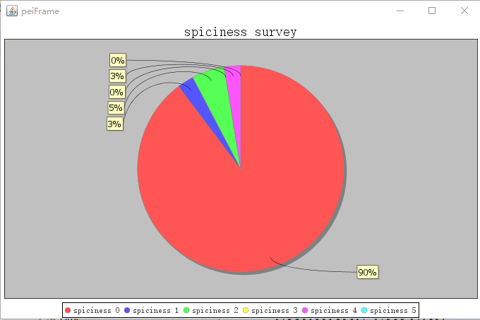

If you press the round button 57e59e300ec34b7fca457b08477ee02, you will get message shows you the sales and survey weekly.